📘 Business Case: David A. Davis Portfolio Website Project

1. Project Overview
This project proposes the design and development of a modern, responsive personal portfolio website for David A. Davis, a BAS-Application Development student at North Seattle College. The portfolio will serve as a professional digital presence showcasing academic projects, technical skills, and industry experience. The site will be built using React + Vite, following modern UI/UX principles and best practices for front-end development.
The project will be completed over a two-week development cycle, with structured planning, component design, implementation, testing, and deployment phases.

2. Problem Statement
Students in the Application Development program are expected to demonstrate their technical capabilities through a professional portfolio. However, David currently lacks a centralized, polished platform to present his work, experience, and skills to instructors, peers, and potential employers.
Without a dedicated portfolio site:
- Projects are scattered across GitHub and Canvas
- There is no unified personal brand
- Employers cannot easily evaluate technical depth or UI/UX thinking
- Academic work is not presented in a professional, accessible format
A portfolio site solves these issues by creating a single, curated location for showcasing David’s development journey.

3. Project Goals
The portfolio website will:
- Establish a professional online identity
- Showcase React projects, assignments, and technical accomplishments
- Highlight industry experience (Amazon LEO, Kuiper, Kymeta, Boeing, etc.)
- Demonstrate UI/UX design awareness
- Provide a clean, modern interface for instructors and employers
- Serve as a long-term asset beyond the AD312 course

4. Scope of Work
The project includes:

In-Scope
- Designing a modern site layout (Hero, About, Projects, Skills, Contact)
- Building the site using React + Vite
- Creating reusable UI components
- Writing content for each section
- Implementing responsive design for mobile and desktop
- Deploying the site to GitHub Pages, Netlify, or Vercel
- Documenting the project in GitHub

Out-of-Scope
- Backend development
- Database integration
- Multi-language support
- Advanced animations or 3D graphics

5. Stakeholders
- Primary Stakeholder:
  - David A. Davis — Developer, designer, and project owner
- Secondary Stakeholders:
  - AD312 Instructor BC Ko
  - Future employers
  - Academic reviewers

6. Benefits

Academic Benefits
- Meets AD312 project requirements
- Demonstrates mastery of React component architecture
- Provides a polished deliverable for grading

Professional Benefits
- Acts as a long-term career asset
- Showcases technical and UI/UX skills
- Strengthens job and internship applications

Personal Benefits
- Builds confidence in front-end development
- Establishes a personal brand
- Creates a foundation for future enhancements

7. Risks & Mitigation

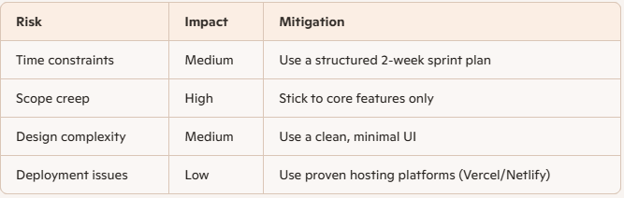

8. Timeline (2-Week Plan)

Week 1
- Day 1–2: Requirements, wireframes, content planning
- Day 3–4: React project setup, component scaffolding
- Day 5–7: Build Hero, About, Skills sections

Week 2
- Day 8–10: Build Projects and Contact sections
- Day 11–12: Responsive design + polish
- Day 13: Deployment
- Day 14: Final testing + documentation

9. Success Criteria
The project could be considered successful if:
- The site is fully deployed and accessible online
- All core sections are complete and visually consistent
- The site is responsive on mobile and desktop
- The GitHub repo includes documentation and commit history
- The final product meets AD312 project expectations

10. Conclusion
This portfolio website project provides a meaningful, high-value alternative to contributing to the NSC Expo site. It aligns with academic requirements, supports long-term career goals, and demonstrates my technical and design capabilities. Completing this project over a two-week development cycle will result in a polished, professional portfolio that could be used beyond the classroom.

Next steps
- User Stories
- GitHub repo structure
- Wireframe layout
- React component plan
- Two-week sprint board

